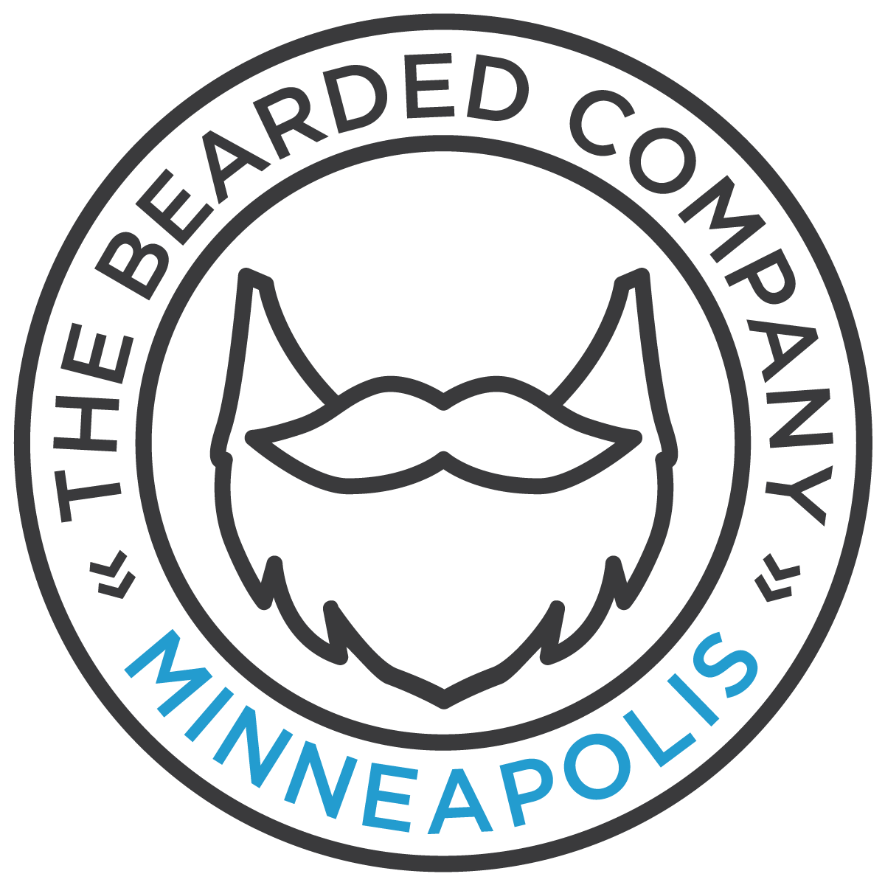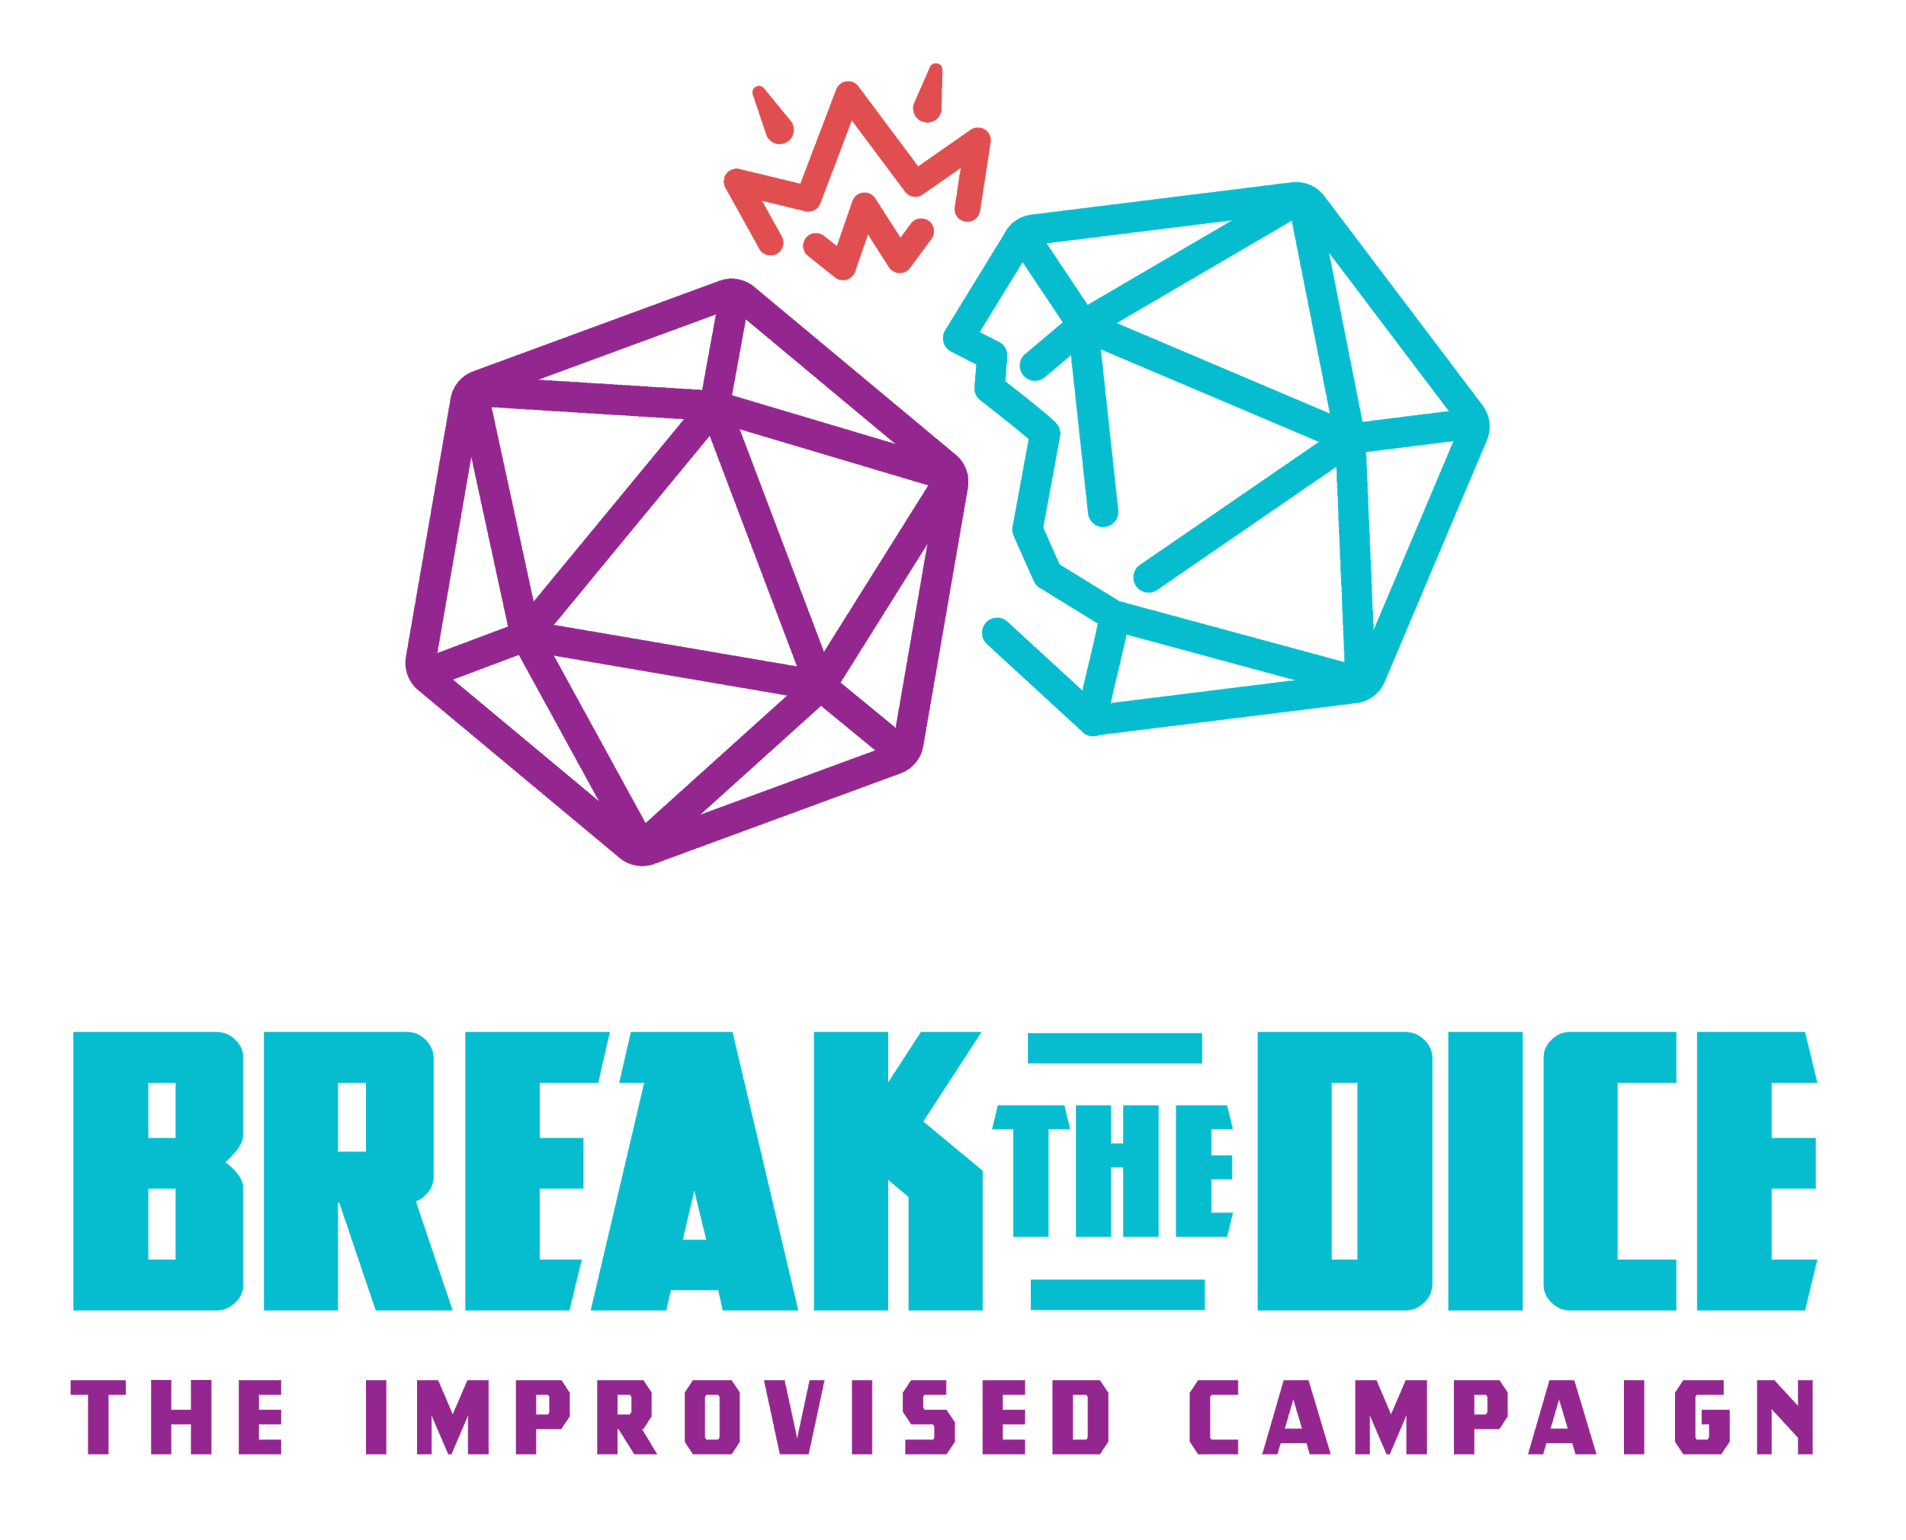**Contact:**

Joe Rapp

The Bearded Company

612-720-6688

jrapp@beardedcompany.org

**FOR IMMEDIATE RELEASE**

IMPROV GROUP LAUNCHES BRAND NEW SEASON OF FANTASY RPG PODCAST  
*Break the Dice* Blends Comedy with Dragon-Slaying in New Ten-Episode Series

**Minneapolis, MN**— The Bearded Company, known for their award-winning narrative improv performances at HUGE Theater in Minneapolis and the Minnesota Fringe Festival, are rolling a +1 persuasion check aiming to take the podcast world by storm by launching the third campaign of their comedy podcast, **Break The Dice**. Break the Dice is an adaptation of their award-winning live show, *Swords and Sorcery: The Improvised Campaign*, an improvised take on classic fantasy tabletop roleplaying games (*cough* D&D *cough*). Since the release of BtD’s first episode in February of 2020, *Break the Dice* has been introducing a brand new world of hilarious fantasy characters to dice lovers everywhere. **Campaign three of Break the Dice launches March 22nd, 2021** and will see two new characters navigate the mysterious realm of Shatterpoint. Campaigns 1 and 2, as well as all future episodes are available on **iTunes, Spotify, Stitcher,** and other podcast platforms.

“Be careful if you like to work out to podcasts, because I almost dropped my 65lb dumbbell on my head laughing at this.”   
- Rush Benson, totally ripped listener

**Making Necromancy Fun Again**

While many fantasy podcasts follow strict tabletop gameplay rules, *Break the Dice* throws caution to the wind and replaces complicated mechanics with the simple role of a 20-sided die. As the improvisers play through the adventure, the Game Master Allen Voigt rolls to see if the character’s decision or action is a success (20) or failure (1). The players then use the specific number as inspiration for how each scenario might play out. The fateful rolls have already led characters to marry witches, stab their allies in the chest with magical swords, and, well… generally make a mess of things. Still the adventure barrels forward as the heroes try to rid the world of the darkest of evils. “That’s the joy of the blend of comedy and high-fantasy. We can be rolling on the floor laughing one minute and then suddenly the mood shifts when we are met with a foe we can’t defeat or a character dies. The oscillation between comedy and high-drama is what this show thrives on,” says **company member Tyler Mills.**

*Break the Dice* is a serialized adventure where each episode builds off of the episodes before it, creating an expanding would that becomes richer with each campaign. Two seasons in, and whole kingdoms have been established that characters move between. With recaps at the top of each episode, listeners can jump in at any point and join the journey without missing a beat. “We think of our stage show as serialized too, but with the podcast, you have any opportunity to go all the way back to the beginning and catch up, or dive in with a new release,” says **Managing Director Joe Rapp**. “It’s that much more exciting to improvise in a world that is constantly expanding that everyone can invest in.”

**Deciding to Destroy Dragons Digitally**

The decision to branch out into the podcasting medium was motivated in large part by the newest member of the company, **Maria Bartholdi**. For the past eight years, she and her podcasting partner Meghan Wolff have been creating a Magic the Gathering podcast called ***Good Luck High Five*** that has become a mainstay in that community. After joining The Bearded Company late last year, Bartholdi saw the podcasting potential to expand the reach of the group’s storytelling style to a wider audience. “Podcasts are an extremely powerful and accessible way to transmit stories,” says Bartholdi. “I wanted to take the energy we all harness on stage and send it out to people who don’t have the ability or opportunity to attend our live shows and create a community around our ridiculous adventures.”

**Improvising in a Socially Distanced World**

The move to a digital medium was made before the COVID-19 pandemic but it has now become a lifeline to the group with the closure of all performance venues in the Twin Cities area. In this time when any public gatherings are impossible, the ability to improvise without a live audience has gone from an experiment to a necessity overnight. “Live performers are searching for ways to continue to create art for audiences they suddenly can’t share a room with,” says **company member Tyler Michaels King**. “We feel very fortunate to have started this journey before the pandemic so that we have a positive place to put our energy right now.”

The group had already recorded four episodes of the podcast before quarantine restrictions were put in place and is now recording the podcast remotely through zoom. The group knows it may be months before theaters will be able to welcome audiences in again and have since increased the frequency of the podcast’s release schedule to twice a month to give listeners more humor to listen to in this time apart. “It’s an incredibly silly thing, even under normal circumstances, to be an adult pretending to be an elf or a goblin,” says **company member MJ Marsh**. “But we also know how powerful it is to smile right now and each time we make each other laugh at a goofy voice or ridiculous magical item feels like a moment we want to share with as many people as we can.”

**###**

**ABOUT THE BEARDED COMPANY:**

Loved locally. Recognized nationally. Since 2006, The Bearded Company have been taking audiences on fully improvised adventures. 2011 brought the Beards to HUGE Theater in Minneapolis where they began to perform weekly. In 2014 the Beards expanded their reach into Los Angeles. Led by Los Angeles based Matthew Pitner (Artistic Director) and Minneapolis based Joe Rapp (Managing Director), the group has created many sold-out shows including *Swords and Sorcery: The Improvised Campaign, Bearded Manor,* and their original form *Epic Adventures.* A mainstay at the Minnesota Fringe Festival, the group holds both the “Artist Pick Award” from the festival as well as “Best Improvised Comedy Award” from Minnesota Playlist. The Bearded Company also performs on tours and in festivals throughout the country and Canada. Whether they’re at their home theaters in LA or Minneapolis, on the road, or online, expect the unexpected.

**ABOUT BREAK THE DICE:**

*Break the Dice: The Improvised Campaign* is an improvised fantasy adventure where the fate of the heroes rests on the roll of a twenty-sided die. Twenty is a spectacular success and one is a critical failure. Each episode is a cannonball dive into the thrilling unknown with characters and creatures spanning the breadth of the fantasy genre. The stories are told through the perspective of two “heroes” with the rest of the cast inhabiting the characters those heroes meet and the Game Master creating the world they play in. The podcast was created by The Bearded Company in collaboration with Game Master Allen Voigt. The original score was created by Jack Barrett.

###

**PODCAST INFORMATION**

**TITLE:** *Break the Dice: The Improvised Campaign*

**AVAILABLE ON:** iTunes, Spotify, Stitcher and other podcast platforms

**RELEASE SCHEDULE:** The Second and Fourth Monday of Every Month

**SUPPORT:** [www.patreon.com/beardedcompany](http://www.patreon.com/beardedcompany)

**CAST/CREATORS**

Maria Bartholdi

MJ Marsh

Tyler Michaels King

Tyler Mills

Joe Rapp

Allen Voigt

**IMPROVISED UNDERSCORE**

Jack Barrett

For more information about The Bearded Company visit: [beardedcompany.org](http://www.beardedcompany.org) or [btdpod.com](https://btdpod.com/)

Images for Press use at high quality resolutions upon request.